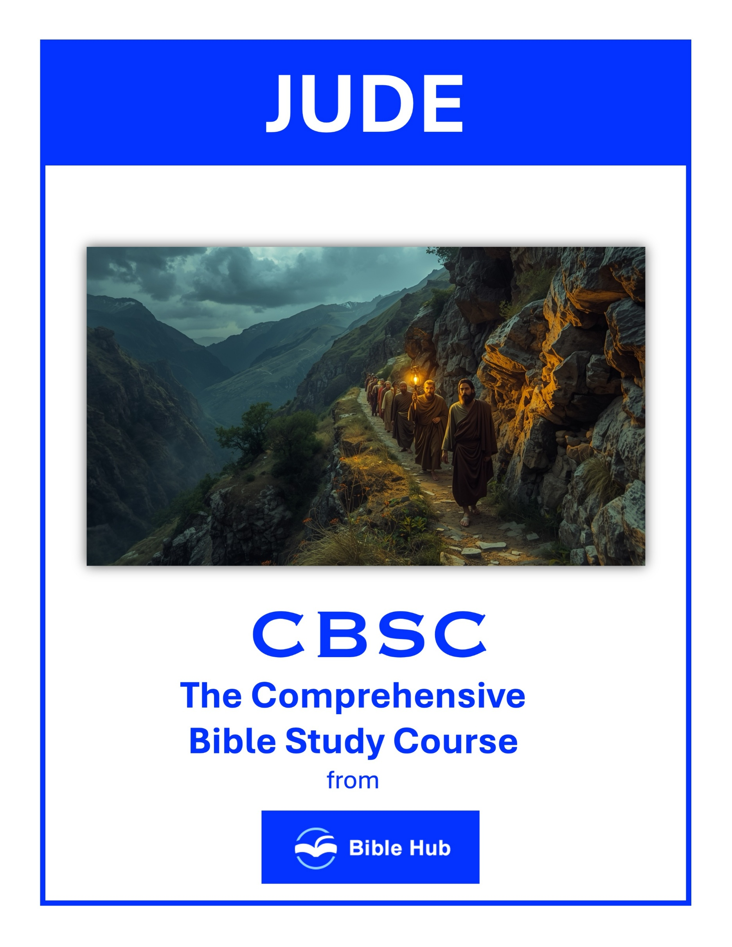

Jude 1 Teaching Points and Bible Study Questions
Contend Earnestly for the Faith
Jude 1:3 urges us to "contend earnestly for the faith entrusted once for all to the saints." This is a call to action, reminding us that our faith is precious and worth defending. In a world filled with distractions and conflicting messages, standing firm in our beliefs is crucial. Just as a soldier defends their post, we are to guard the truth of the Gospel with passion and dedication.
1. How can you contend earnestly for the faith in your daily interactions with others?
2. Why do you think it's important to defend your beliefs in today's society?
3. What practical steps can you take to strengthen your faith against challenges?
Beware of False Teachers
Jude warns us about those who "pervert the grace of our God into a license for immorality" (Jude 1:4). It's essential to be discerning and vigilant, recognizing that not everyone who claims to speak for God truly does. By staying rooted in Scripture, we can identify and avoid teachings that lead us astray, ensuring that our spiritual journey remains on the right path.
1. How can you discern false teachings in your daily life and protect your faith community?
2. Why do you think false teachers are so persuasive, and how can you resist their influence?
3. What practical steps can you take to ensure you are grounded in true biblical teachings?

Remember Past Judgments
Jude 1:5-7 reminds us of historical examples where God judged those who turned away from Him. These stories serve as powerful reminders of the consequences of disobedience. By reflecting on these past events, we can learn to avoid similar pitfalls and remain faithful to God's commands, knowing that His justice is both righteous and inevitable.
1. How can remembering past judgments influence your daily decision-making and spiritual growth?
2. Why do you think recalling God's past judgments is crucial for maintaining faithfulness today?
3. What can you learn from past judgments to avoid repeating similar mistakes in your life?
The Importance of Humility
In Jude 1:9, we see the archangel Michael displaying humility, even in a dispute with the devil. This teaches us the value of humility in our spiritual battles. Instead of relying on our strength, we should depend on God's power and wisdom. By adopting a humble attitude, we can navigate life's challenges with grace and integrity.
1. How can practicing humility help you build stronger relationships within your community?
2. Why do you think humility is essential in recognizing and respecting others' perspectives?
3. What steps can you take to cultivate humility in your daily interactions?

The Danger of Grumbling and Faultfinding
Jude 1:16 warns against those who "grumble and complain, following their own evil desires." It's easy to fall into the trap of negativity, but this attitude can lead us away from God's purpose. By cultivating gratitude and focusing on God's blessings, we can maintain a positive outlook and strengthen our relationship with Him.
1. How can you address grumbling in your life to foster a more positive community around you?
2. Why do you think faultfinding can harm relationships, and how can you avoid it?
3. What practical steps can you take to replace grumbling with gratitude in daily situations?
Build Yourself Up in Faith
Jude 1:20 encourages us to "build yourselves up in your most holy faith and pray in the Holy Spirit." This is a reminder that spiritual growth requires intentional effort. By engaging in regular prayer, Bible study, and fellowship with other believers, we can strengthen our faith and deepen our connection with God.
1. How can you incorporate daily practices to strengthen your faith as described in Jude 1?
2. Why do you think building yourself up in faith is crucial for facing life's challenges?
3. What practical steps can you take to ensure your faith remains strong and active?

Keep Yourself in God's Love
Jude 1:21 instructs us to "keep yourselves in the love of God as you await the mercy of our Lord Jesus Christ." This involves actively nurturing our relationship with God and living in a way that reflects His love. By doing so, we can experience the peace and joy that come from being in His presence.
1. How can you actively keep yourself in God's love amidst daily distractions and challenges?
2. Why do you think maintaining faith is crucial for staying in God's love?
3. What practical steps can you take to build yourself up in faith and love?
Show Mercy to Others
Jude 1:22-23 calls us to "show mercy to those who doubt" and "save others by snatching them from the fire." This highlights the importance of compassion and outreach. By extending grace and understanding to those who are struggling, we can be instruments of God's love and help guide them toward salvation.
1. How can you practically show mercy to those who doubt or struggle in their faith today?
2. Why do you think showing mercy is essential in building a compassionate community?
3. What steps can you take to balance mercy with accountability in your relationships?

Be Aware of Spiritual Warfare
Jude 1:9-10 reminds us that spiritual warfare is real, and we must be prepared. By putting on the full armor of God and staying alert, we can stand firm against the enemy's schemes. Recognizing the spiritual battle around us helps us remain vigilant and reliant on God's strength.
1. How can you recognize and resist spiritual deception in your daily life?
2. Why do you think it's important to contend for your faith amidst spiritual challenges?
3. What practical steps can you take to strengthen your spiritual defenses against false teachings?
Praise God for His Sovereignty
Jude concludes with a powerful doxology, praising God for His ability to "keep you from stumbling and to present you blameless" (Jude 1:24-25). This is a beautiful reminder of God's sovereignty and faithfulness. By trusting in His power and grace, we can walk confidently in our faith, knowing that He is in control and will guide us to eternal life.
1. How can you recognize and praise God's sovereignty in your daily challenges and decisions?
2. Why do you think acknowledging God's sovereignty can impact your response to life's uncertainties?
3. What practical steps can you take to trust in God's sovereign plan during difficult times?

